**Docker Compose commands:**

docker-compose up -d

docker-compose down

**how to see whats inside the docker container:**

* inside the DIR you have the docker-compose.yml file
* nano it or cat it to view the file
* inside the YML you will see the DB name and username and password.

**How to run the docker container: NOTE = you must be in the correct Directory**

* docker exec -it < NAME of Database > bash
* example: exec -it activitydb bash

**How to reset a docker:**

* Docker-compose reset

**How to restart a docker:**

* Docker-compose restart

**How to show your docker containers:**

* Docker ps

**How to kill dockers:**

* Docker kill wp or db

**How to log into the container:**

* use the username and password that is documented inside the YML

file

* mysql -u < USER NAME > -p <PASSWORD> -D < Name of DataBase>
* Example: mysql -u admin -p123456 -D goodcorpdb

**Once inside the MySQL session: My Sequal:**

* Note: make sure to use ; to execute command

Examples of some basic searches:

* Select * from (type what your looking for like employees)
* SELECT * FROM employees WHERE Department = 'Research and Development';
* SELECT * FROM employees WHERE ID=’3’;
* Show databases;
* Show tables;
* **REMEMBER** to use “single ticks” or ‘ when defining values
* **REMEMBER** that employees or Department or ID are in the table you are searching from and will be different but the concept remains the same

**How to insert information:**

* Example:

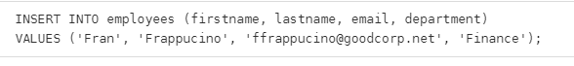

**How to Delete:**

* DELETE FROM employees where Id='1';